Classification of Humans

# Australopithecines

* Probably spent time in the trees
* Features that propose this
  + Slightly less efficient
  + Upper limbs are slightly longer
  + More curvature on the hands, allowing for easier gripping of branches
* Sexually dimorphic
* 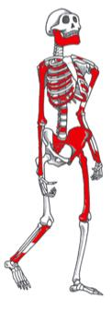 Female
  + - * Height: 3’ 6”
      * Weight: 65 lbs
*  Male
  + - * Height: 5’
      * Weight: 100 lbs
* Had ape-sized brains
  + About 450 cubic centimeters which is about one pint of beer
  + Humans have 1450 cubic centimeters which is about three pints of beer
* Teeth and jaws were intermediate between chimps and humans

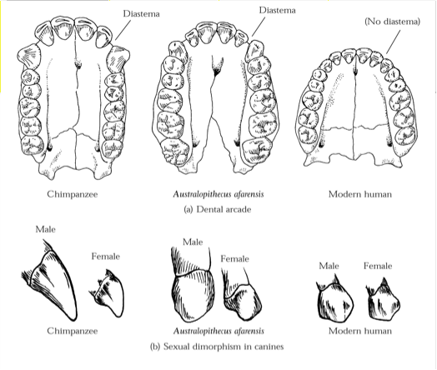

* + Australopithecines show subnasal prognathism like chimps

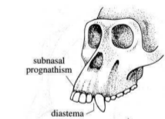

* **Lineage**: Chimp → Australopithecines → Humans
* Had ape-like developmental patterns
  + Slower life history
  + Not nearly as slow as humans
* Selections reorganized Paranthopine skulls and jaws for chewing
  + **Zygomatic arches**: flared cheekbones
    - Need big mouth muscles to chew hard material
  + Sagittal crest: ridge on top of the skull
  + Large molars

# Au. Afarensis

* 3.9 - 3.2 MYA
* Features midway between humans and chimps
  + Pelvis is more human like
  + Upper body is more ape like
* Fossils found: Selam, Lucy, Dikika child, footprints at Laetoli
* Lucy

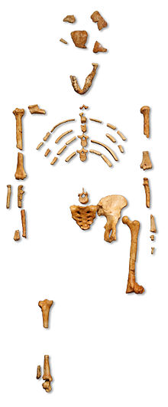

* Selam

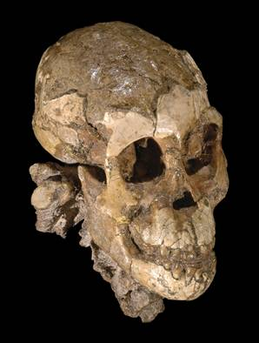

* Earliest tools use attributed
  + Bone/horn/tooth tools and weapons
  + Early associated with theories of violent origins
* Possible ancestor to later hominids
  + Example: *Au. Africanus*, *Homo*
* About half the size of a modern human

# Au. Sediba

* 1.97 - 1.78 MYA in South Africa
* The last of the *Australopithecines*
* Small bodied and brained along with longer arms
* *A. Africanus*
  + 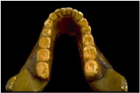
* *P. Boisei*
  + 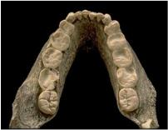 Much larger molars
* **Temporalis muscle**: one of the muscles of mastication (chewing)